# Model My Watershed App

WikiWatershed

Day 2

*Model My Watershed* is a powerful new tool created by the [Stroud Water Research Center](http://www.stroudcenter.org/) that relates demonstrates the relationship of land and water. It has some sophisticated models working behind the scenes to allow you to choose an area and:

* describe the area with national datasets showing land cover and soils
* model the runoff quantity and quality for the area using different storm sizes
* compare the current runoff conditions to those in scenarios that you create with tools that can alter the land cover and/or install conservation practices in the area

See also Stroud Center’s Online Guide:

<https://wikiwatershed.org/documentation/site-storm-guide/>

### Model YOUR Watershed

In this activity, you will use the Model My Watershed App to simulate stormwater runoff and water quality on your school property.

* Open the **Model My Watershed** app from the Wikiwatershed home page or by typing <https://app.wikiwatershed.org/> into a browser window.

[**https://app.wikiwatershed.org/**](https://app.wikiwatershed.org/)

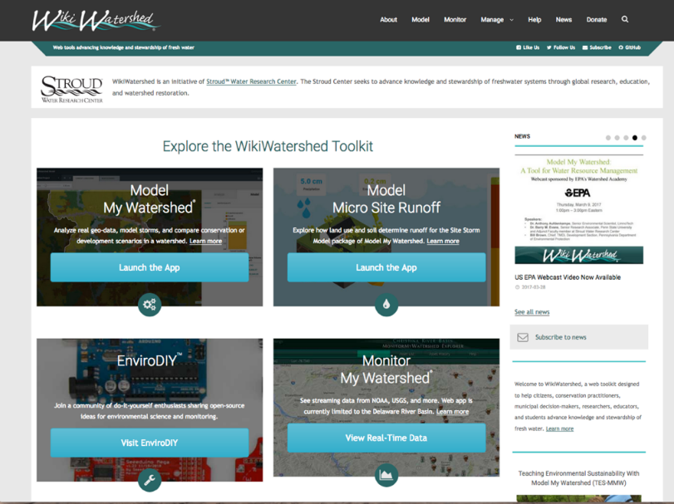

### ../Screen%20Shot%202017-07-24%20at%2010.02.53%20AM.png

* Create an account if you haven’t done that already (Login box, upper right). You may need to log into your email to verify your account before going on to the next step. Write down your user name and password for safe keeping.

Username __________________

Password __________________

* Once you are logged in, press the **GET STARTED** button.
* Use the **search box** to locate your high school using an address or place name. Or, you can just pan and zoom to it.
* Once you are zoomed to your campus, **change your base map** from the **Layers** box on the map. Choose “Satellite with Roads” for a base map. Once the base map updates, **minimize** the Layers box to see more of your screen by clicking the small down arrow to the right of the word Layers.

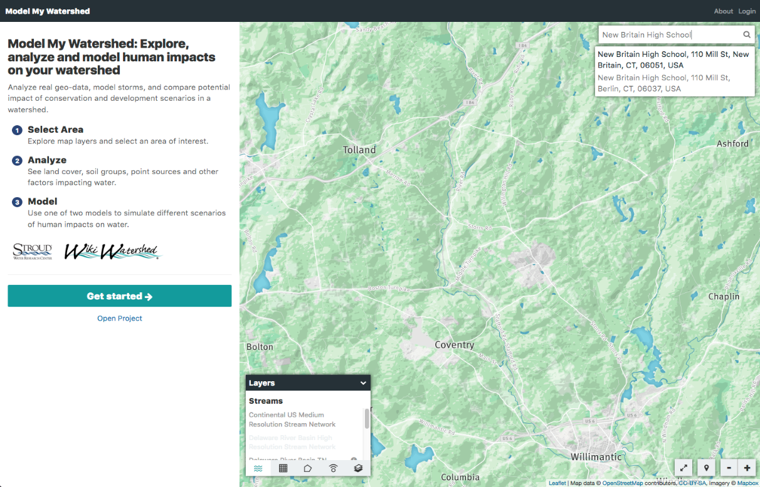

search box

After you zoom into your area of interest, choose a satellite image for your background. Then minimize the Layers box.

There are several ways to delineate the area that you’re modeling, but the best ones for a small area like a high school campus are the “Draw Area” tools. You can choose a point (like the center of the school) and have the tool draw a 1 square km box around it (Square Km), or, better yet, you can draw your own outline of the campus (Free Draw). Let’s take a look.

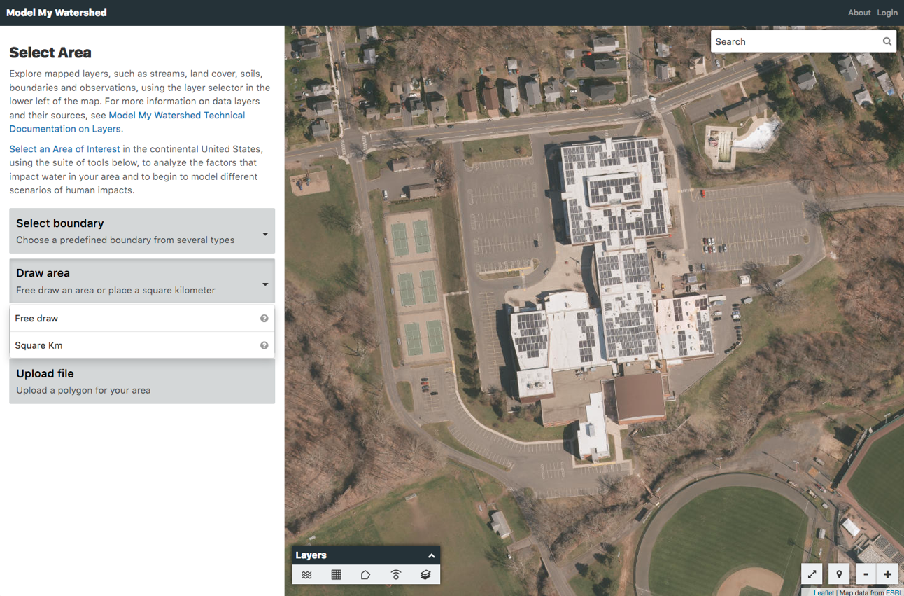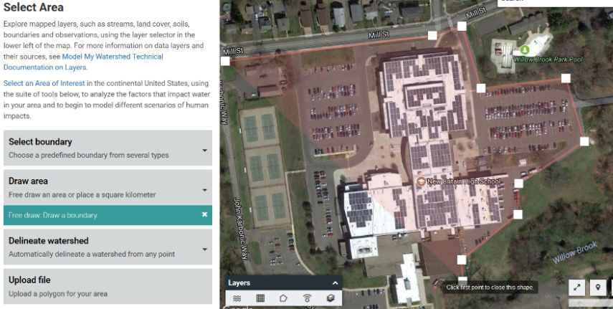

* Click on the **Draw area** box and select the **Free draw** tool.
* Hover your mouse over the map on one corner of your campus and click to place your first point.
* Delineate your campus boundary by continuing to click along the outside edge of the campus (your best guess will do). Click on your first point to close the shape.

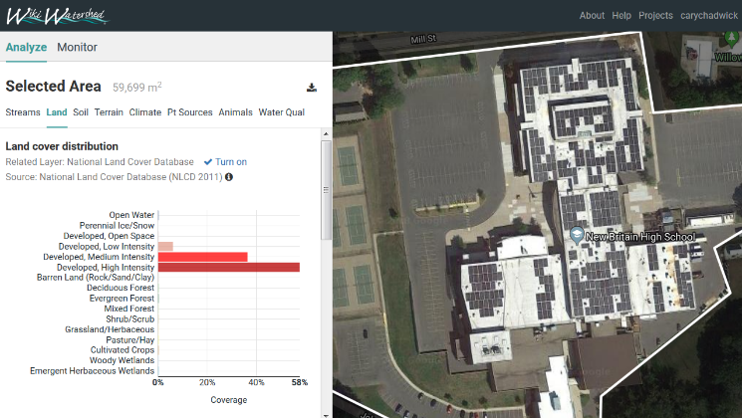

* The Model My Watershed tool will generate statics for a number of variables once your shape is complete. Take a minute to explore the estimated **Land cover** and **Soil** distribution on your campus.
* Once you have delineated your campus and explored the land and soil distribution, click on **Select a Model** and choose **Site Storm Model**. The frame will automatically calculate the runoff of the current site from a hypothetical 24 hour storm and display it in a bar chart.

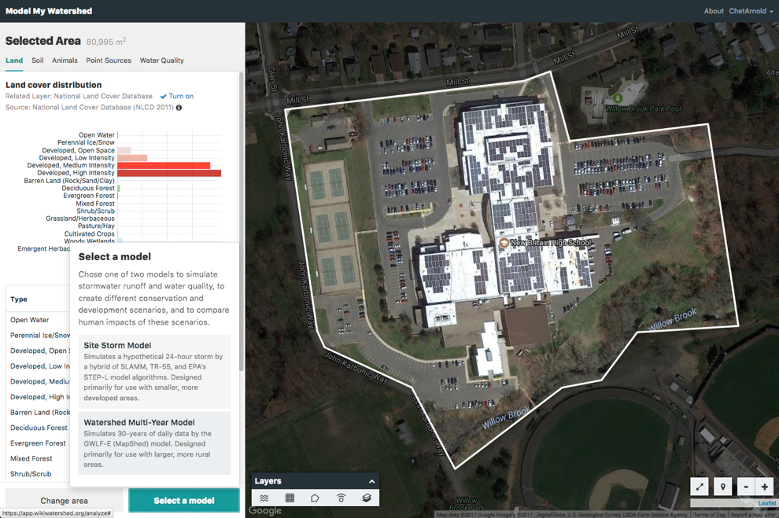

* Take a minute to explore the **Runoff model**. Hover your mouse over the bar chart to see the estimated runoff values for the current condition. Note that you can change the magnitude of the simulated storm event by adjusting the Precipitation slider at the top right. Note it may take a few seconds for the model to recalculate.
* Now is a good time to **name your project** by clicking on the “Untitled Project” pull-down menu in the upper left-hand corner.
* Switch from Runoff to the **Water Quality** simulation to view the estimated loads delivered during a 24-hour storm event.

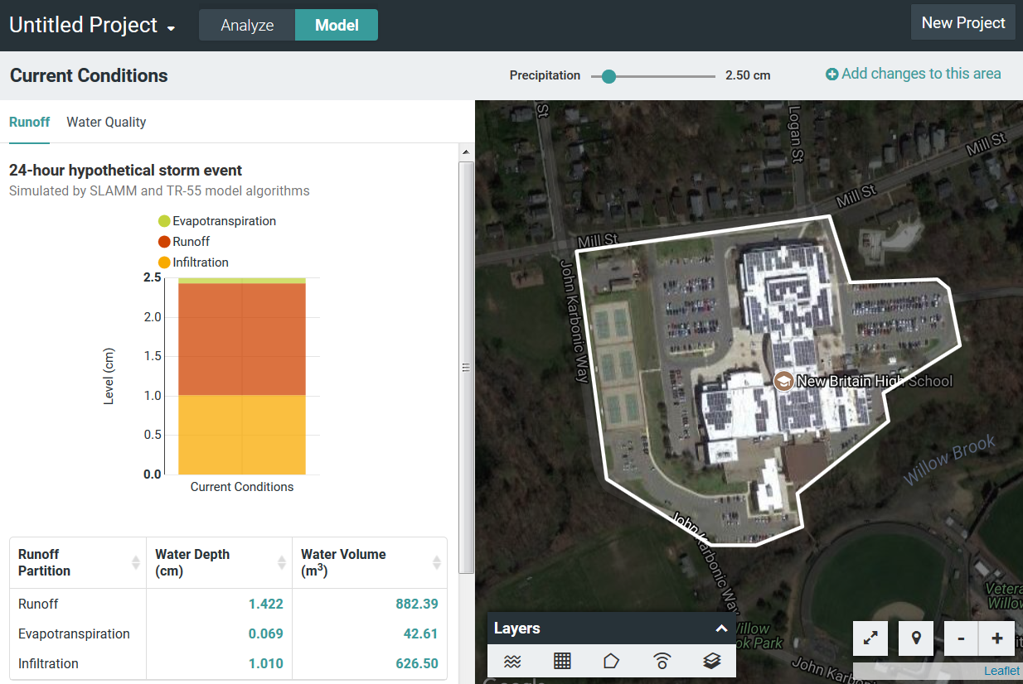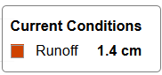

Hover mouse

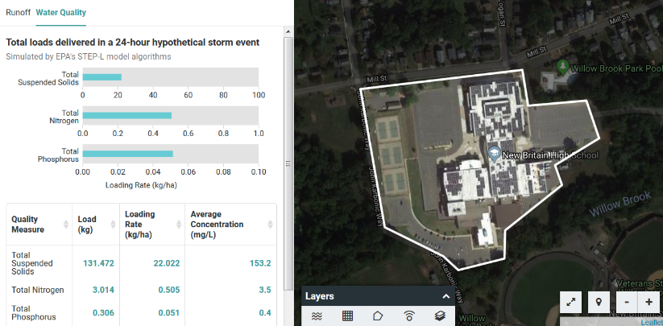



### Create Your Own Scenario

Now, HAVE AT IT! In this next step, you will remake your school campus by adding conservation practices and/or changing the land cover to see how it changes the quantity and quality of the runoff generated on the property.

* Click on the **Add changes to this area** link in the upper right hand corner of the tool. Your **New Scenario** (upper left) will be a copy of your “current conditions” that can be altered.

click this link to start making new scenarios

* Two **new tool boxes** will appear: “Land Cover” and “Conservation Practice.”
* Click on **+Conservation Practice** and select **Porous Paving.**

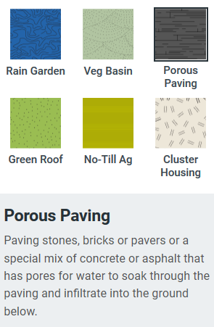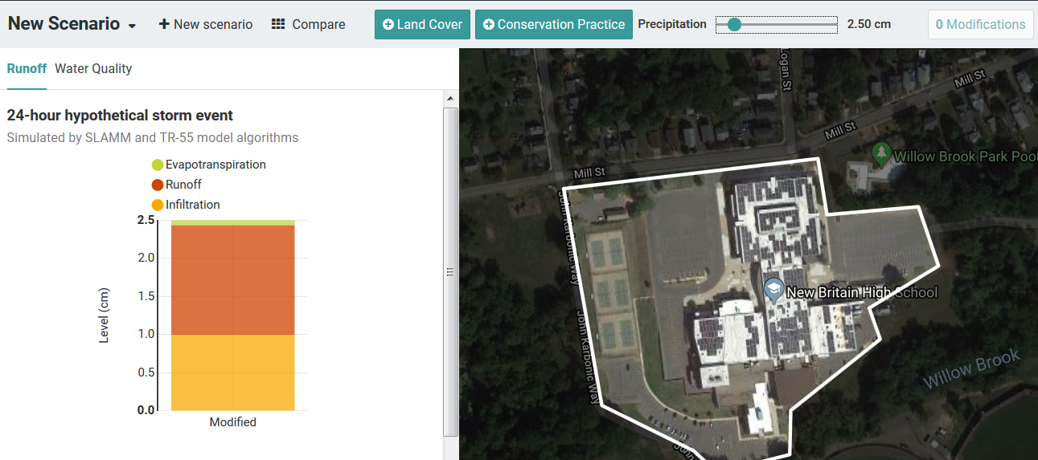

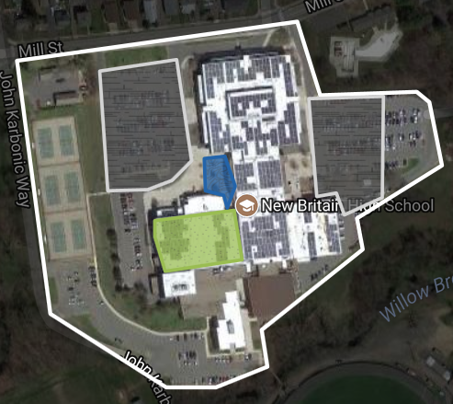

* Change one of the parking areas on campus from traditional paving to porous paving. Click in a corner of the parking lot to get started. Delineate the area by continuous clicks, returning to the first point to close the shape. The runoff model will update once the new conservation practice has been added. Notice you can also change the Precipitation amount.
* Before we compare the scenario changes, add a second Conservation Practice. Try a Green Roof or Rain Garden…or both.
* 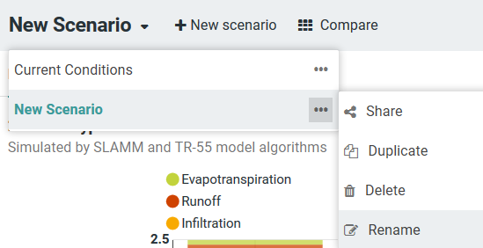Before we compare our changes to the Current Conditions, let’s rename this scenario to avoid confusion. Click on the **small black arrow** next to the words “New Scenario” in the upper left corner of the project. Click on **three dots** next to “New Scenario” and select **Rename**. Name the scenario **LID Practices**.
* If you’re feeling ambitious, you may wish to add (change) land cover on campus using the **+Land Cover** button. Perhaps there is a big wetland on campus that is not being accounted for, or planned development on campus that could be added.

### Compare Scenarios

* Click on the **Compare icon**.

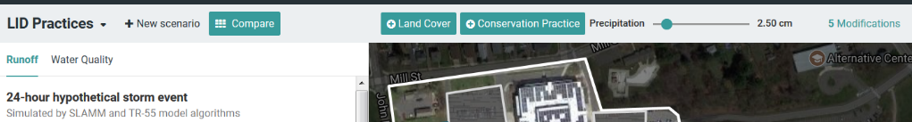

A new window will open showing a comparison of three scenarios – Predominantly Forested, Current Conditions, and your new LID Practices. This window allows you to efficiently compare both the **Runoff** and **Water Quality** models generated for the three scenarios. Note you can also still change the size of the storm event by adjusting the **Precipitation** amount.

* Use the image on the following page to explore your results in depth.
* You can always go back and add more changes, or create yet another scenario with a different suite of changes by clicking the Back button.

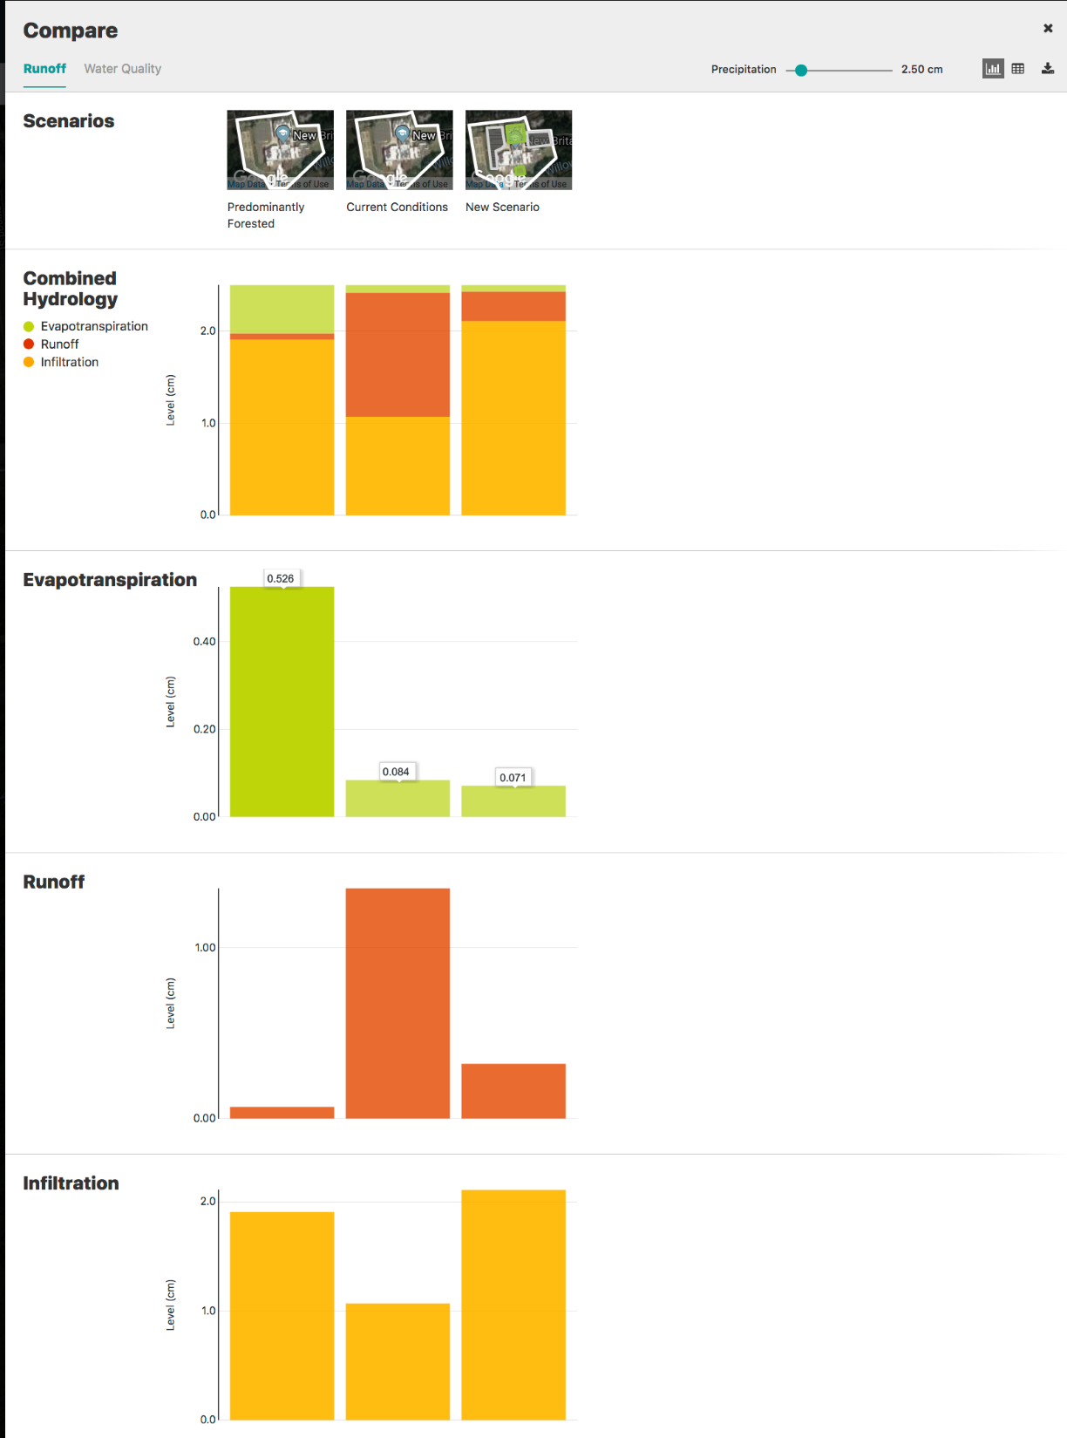

Use precipitation slider to increase or decrease storm event

Hover mouse over bar graph to see levels

Displays all of your scenarios you’ve created, plus Predominantly Forested conditions for comparison

Choose Runoff or Water Quality Comparison

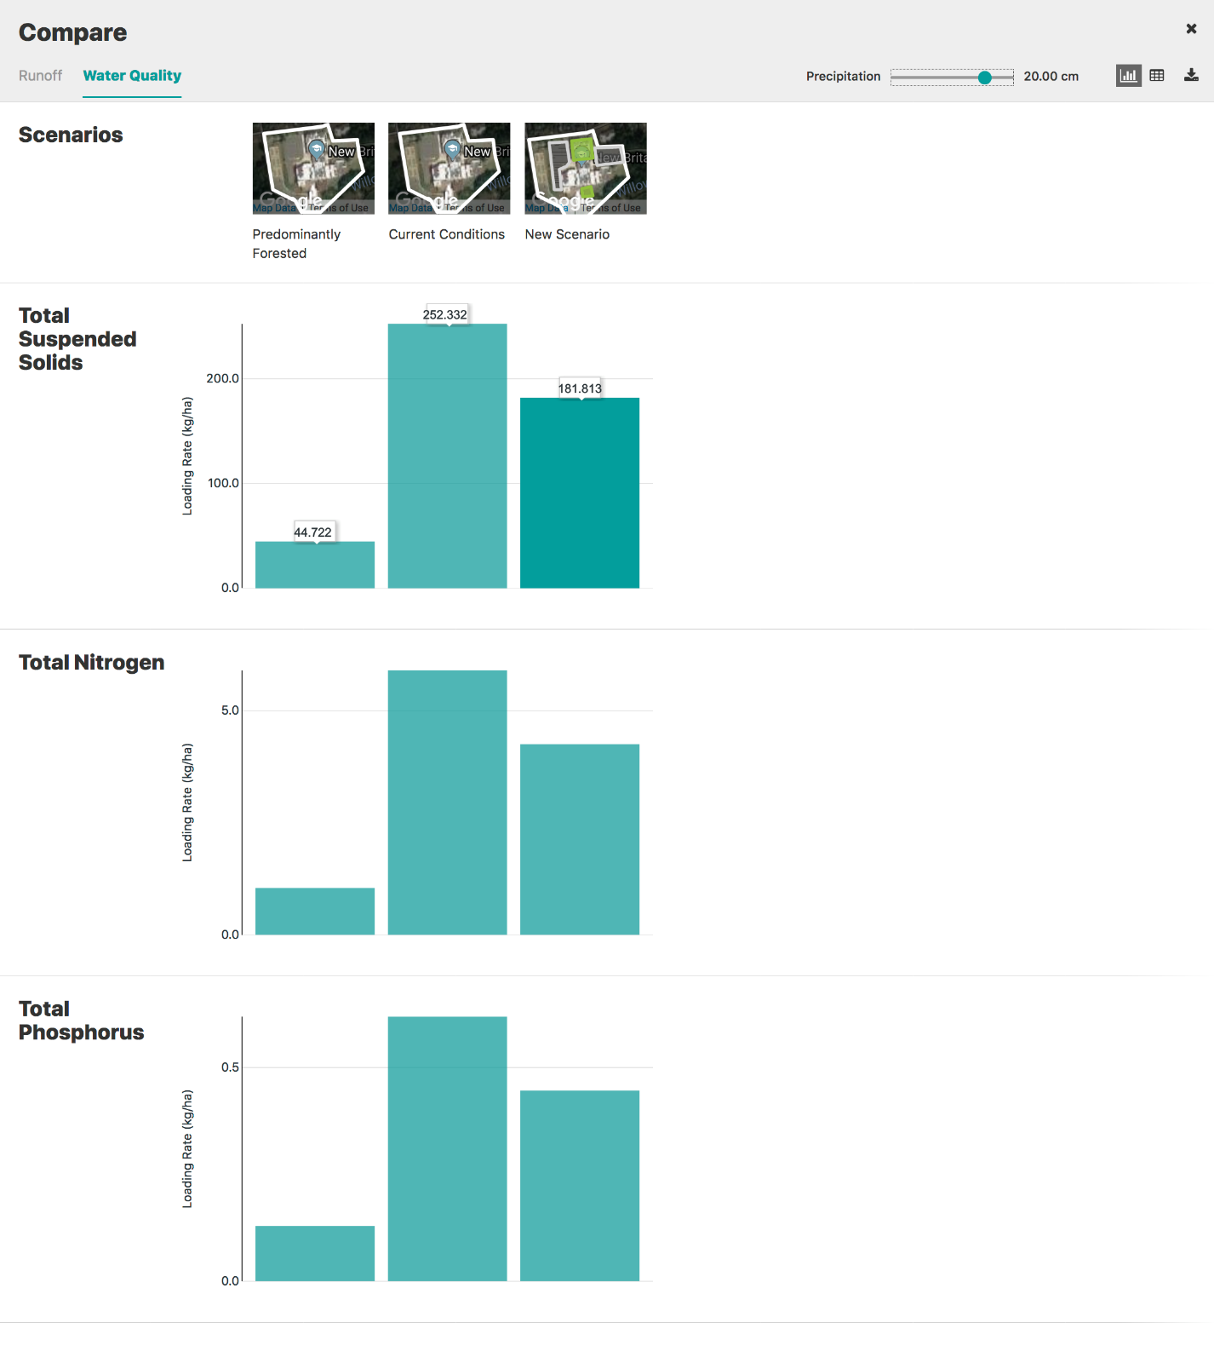

CAUTION: scale on bar graph changes to accommodate the results!

Be sure to check out Water Quality Comparison

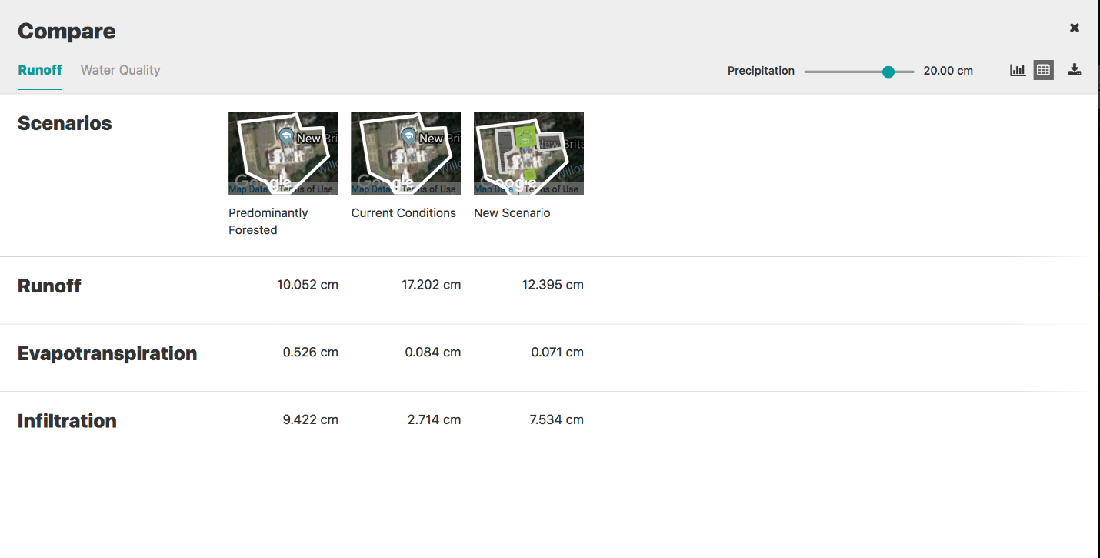

You can also view results in a table format or download them as a CSV file (compatible with Excel).

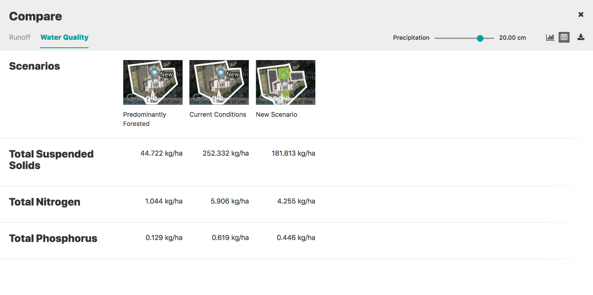

### Thinking about your results:

1. If you added LID practices in your scenario, how much were you able to decrease the runoff from your campus? How close was this to the 100% Forest Cover baseline?

2. Test your comparative results in a modest rainstorm (5 cm) versus a gully-washer (25 cm). What happens to the differences between your scenarios, in terms of runoff? Why?

3. What are the best LID opportunities on your campus? If you could build a rain garden or two, where would they go?

4. What did you like best about this tool? What did you like least? Do you think it would be a good teaching resource for your students? Why or why not?